## horizontal line



Predicting IMDb Scores

**PHASE 5**

**NAME:**

**S.Merlyn kerenab**

**N.Gayathri**

**D.Naveena**

**A.Divya Bagya Laxmi**

**M.Harini**

**1/11/2023**

Problem Statement and Design Thinking Problem

# Problem Statement:

The problem is to develop a machine learning model that predicts IMDb scores of movies available on Films based on features like genre, premiere date, runtime, and language. The objective is to create a model that accurately estimates the popularity of movies, helping users discover highly rated films that match their preferences. This project involves data preprocessing, feature engineering, model selection, training, and evaluation.

**Design Thinking:**

1. **Data Source**:

Utilize a dataset containing information about movies, including features like genre, premiere date, runtime, language, and IMDb scores.

2. **Data Preprocessing**:

Clean and preprocess the data, handle missing values, and convert categorical features into numerical representations.

3. **Feature Engineering**:

Extract relevant features from the available data that could contribute to predicting IMDb scores.

4. **Model Selection**:

Choose appropriate regression algorithms (e.g., Linear Regression, Random Forest Regressor) for predicting IMDb scores.

5. **Model Training**:

Train the selected model using the preprocessed data.

6. **Evaluation**:

Evaluate the model's performance using regression metrics like Mean Absolute Error (MAE), Mean Squared Error (MSE), and R-squared.

Dataset Link: <https://www.kaggle.com/datasets/luiscorter/netflix-original-films-imdb-scores>

Based on the given dataset and the strategy planned, a machine learning model to predict IMDb scores of available movies by a certain criteria will be built such that it provides a better user expend improved.

**About the Dataset**

This dataset consists of all Netflix original films released as of June 1st, 2021. Additionally, it also includes all Netflix documentaries and specials. The data was web scraped from [this](https://en.wikipedia.org/wiki/Lists_of_Netflix_original_films) Wikipedia page, which was then integrated with a dataset consisting of all of their corresponding IMDB scores.

### **Content**

Included in the dataset is:

· Title of the film :

It consist of the Title of the film

· Genre of the film

It consist of the category of genre the film falls into

· Original premiere date

It consist of the date, month and year the film was first premiered

· Runtime

It consist of the runtime in minutes

· IMDB scores

It consist of the IMDb rating of movies as of 06/01/21

· Languages

It consist of the languages currently available as of 06/01/21

**Implementation**

Data preprocessing is a crucial step in any data analysis. This process involves cleaning and transforming the raw data to make it suitable for analysis. In this report, we will outline the key steps and techniques for data preprocessing in Python using various libraries, primarily Pandas and NumPy.

**Code**

**1.Loading the required modules**

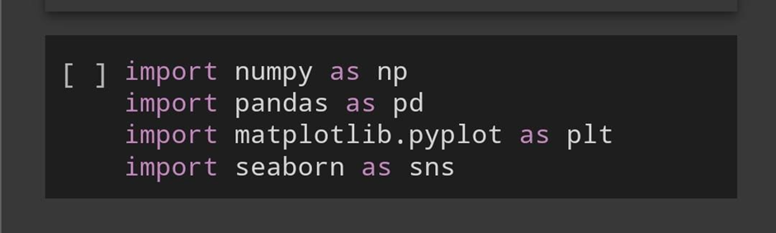

**2.Loading the Dataset**

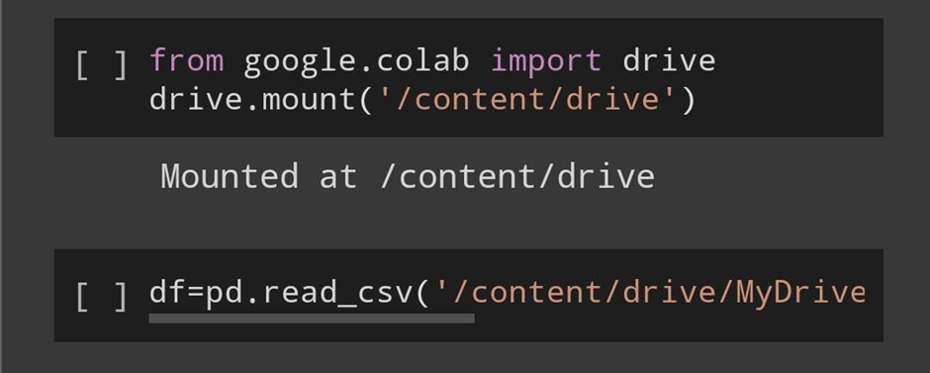

**3. Understanding the dataset**

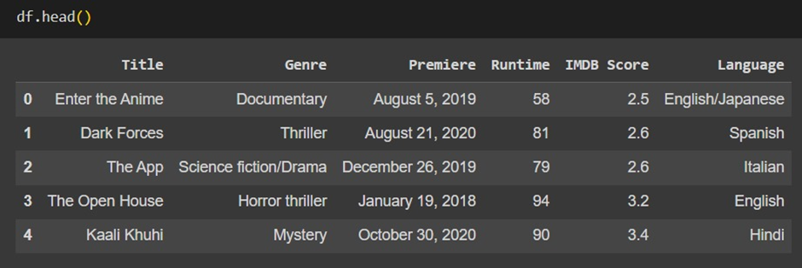

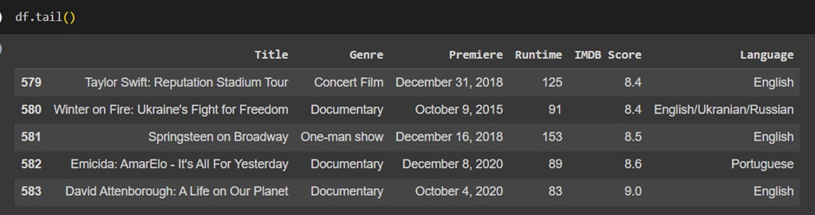

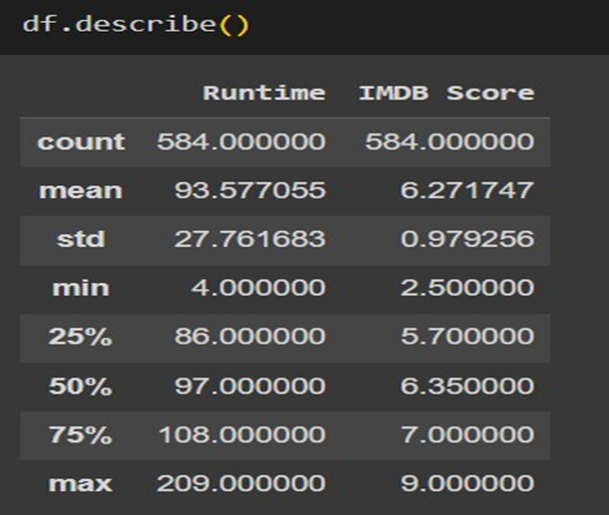

*The number rows and columns*

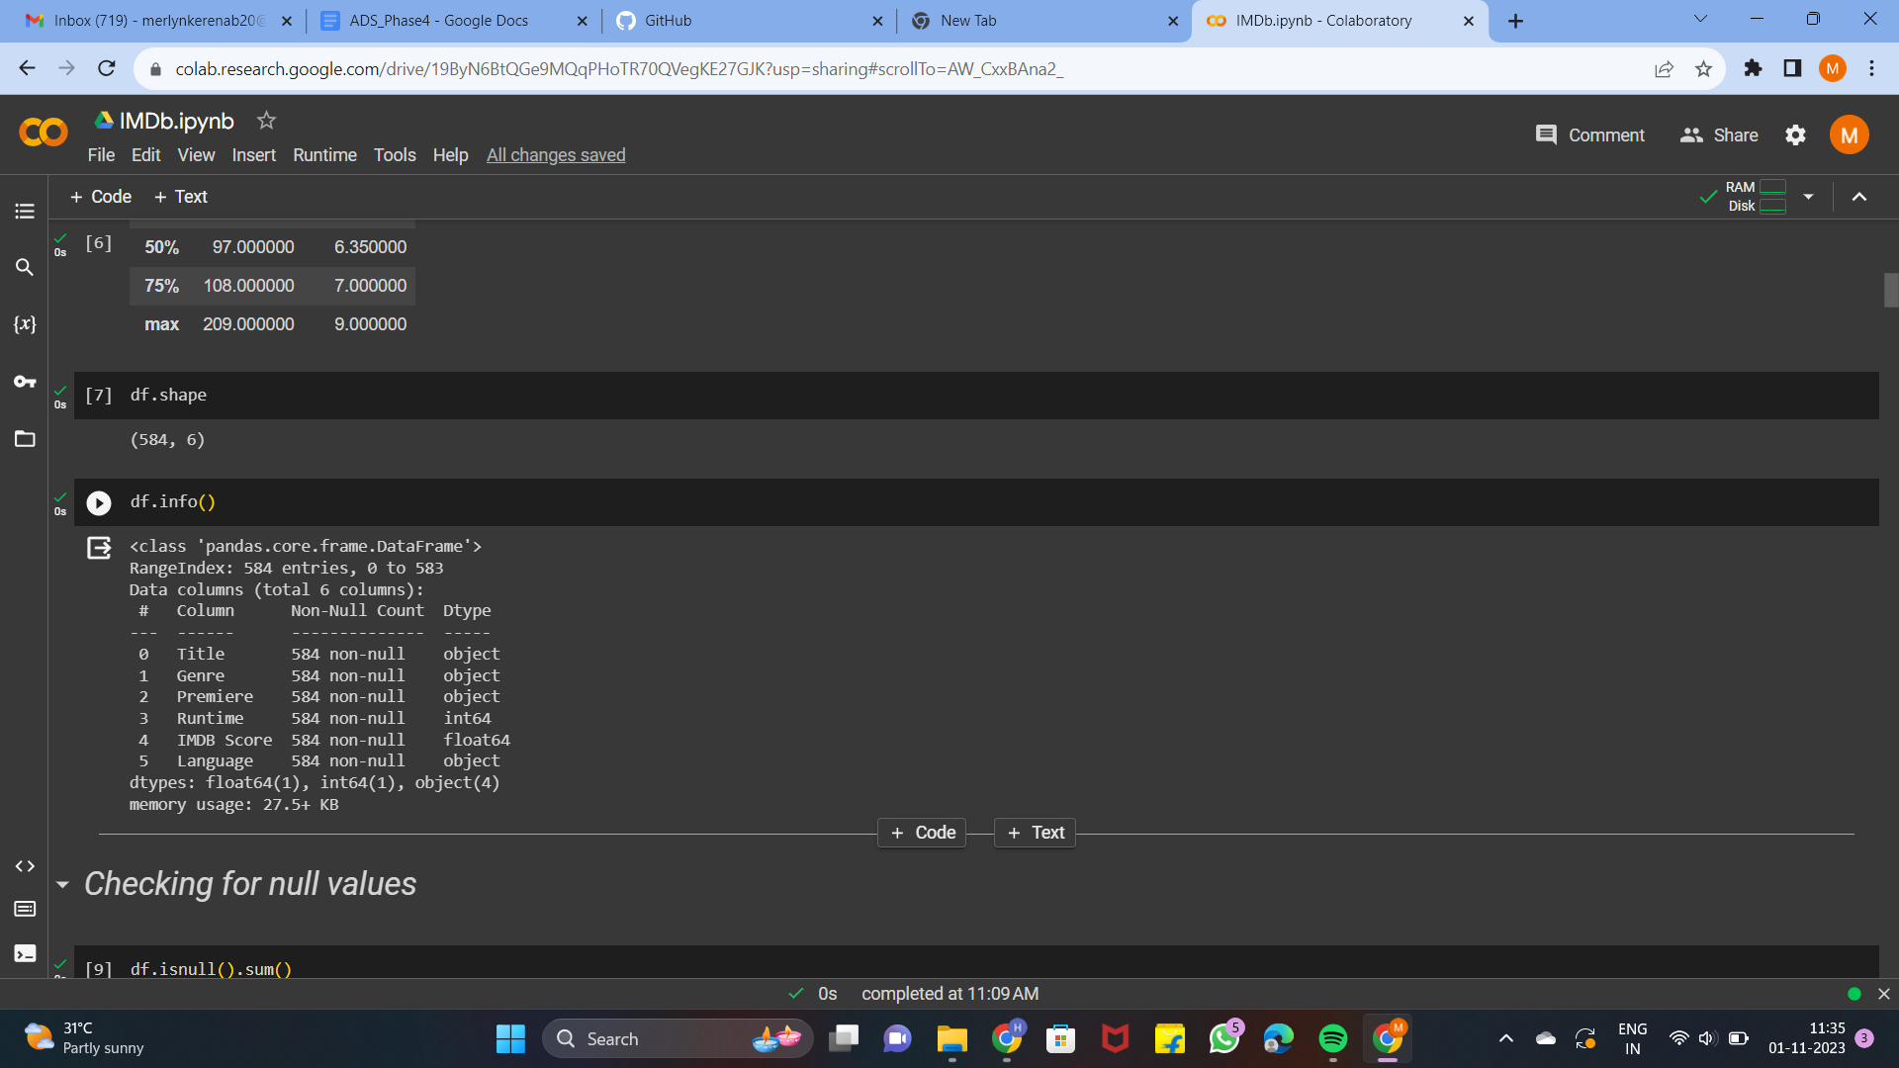

**

**4.Checking for null values**

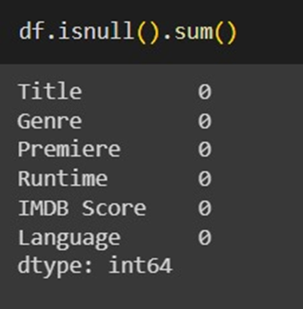

**5.Checking for duplicate data**

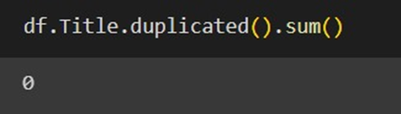

**6.Performing analysis**

*The names of the columns present in the dataset*

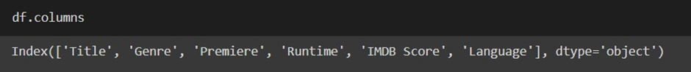

*The number of movies in each genre*

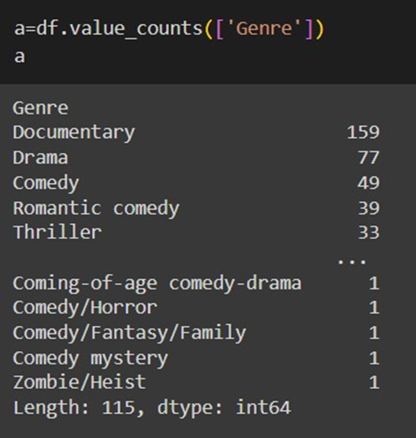

*The number of films in each language*

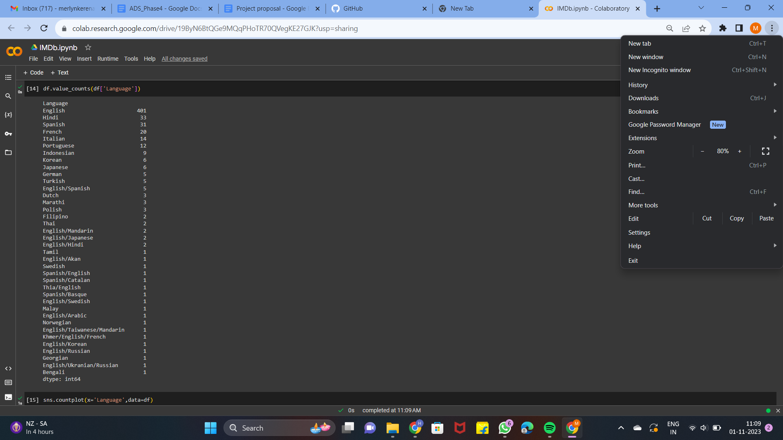

*The highest number of films in a Language*

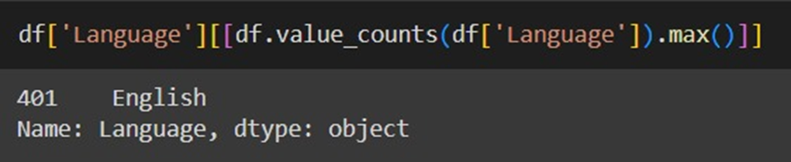

*Countplot for number of films in each language*

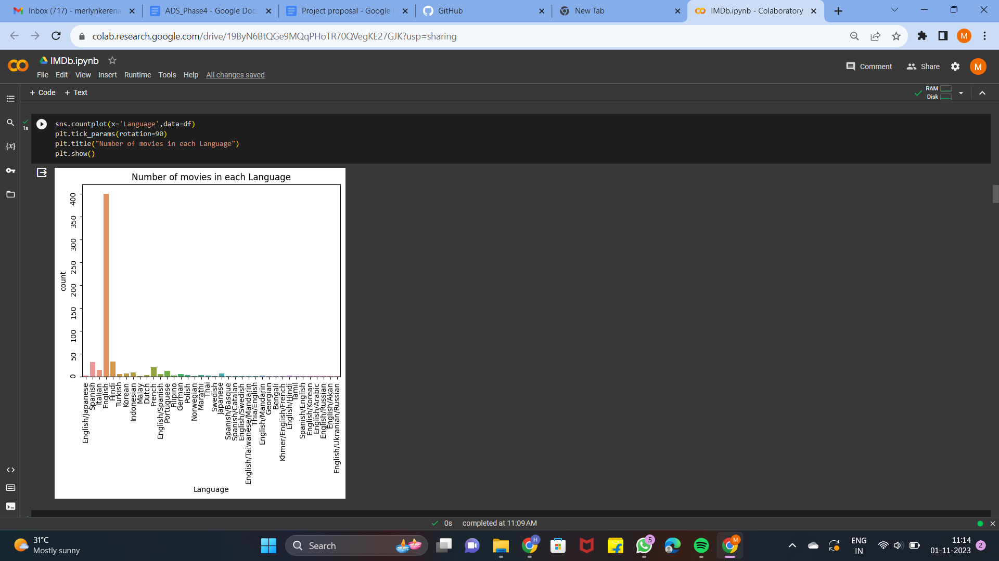

*Grouping Top 10 films with highest rating*

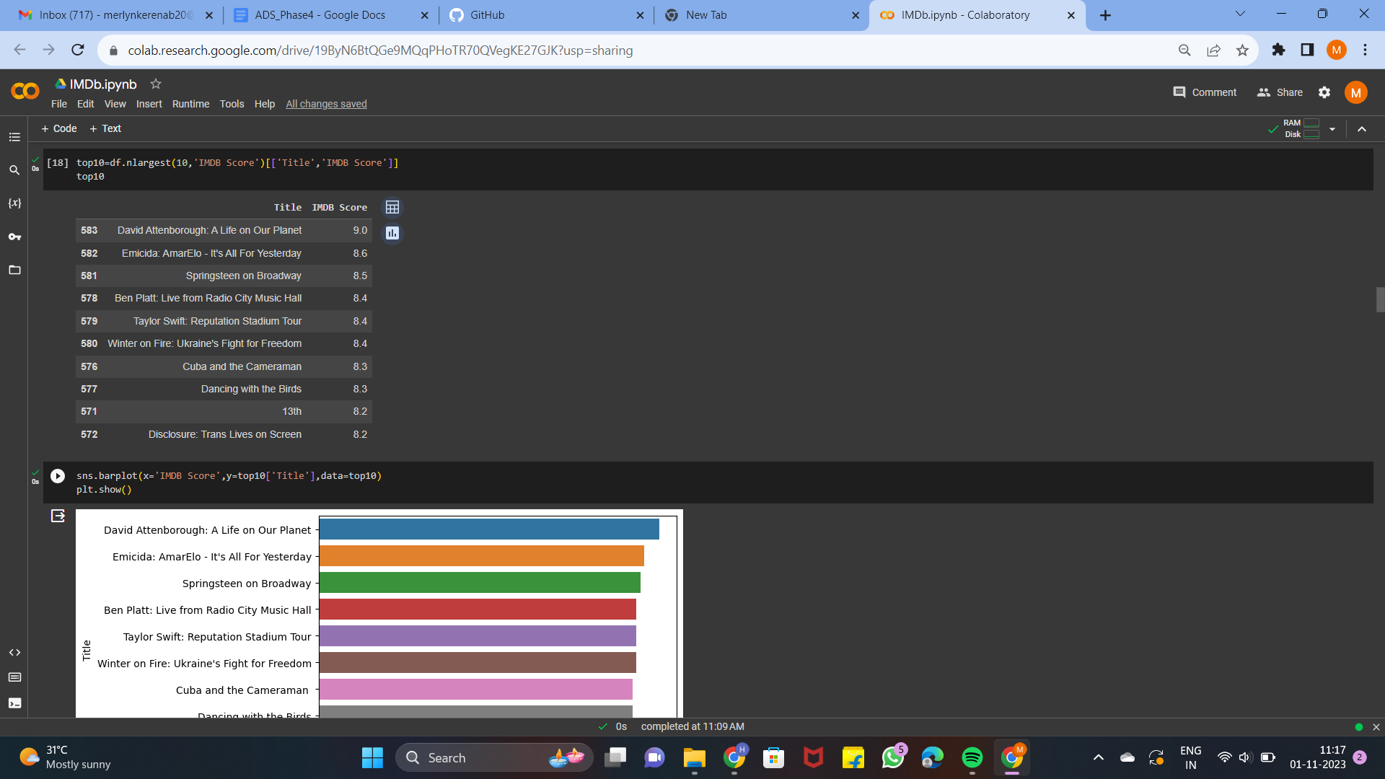

*Plot for the top 10 highest rated films with their titles*

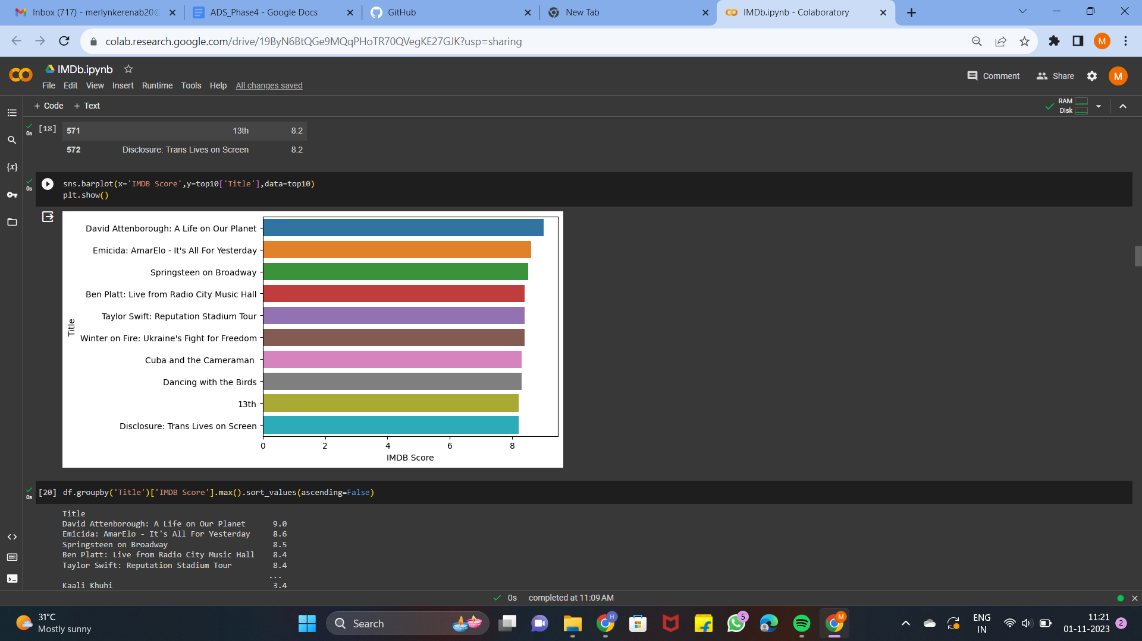

*The rating of each film with their title in descending order*

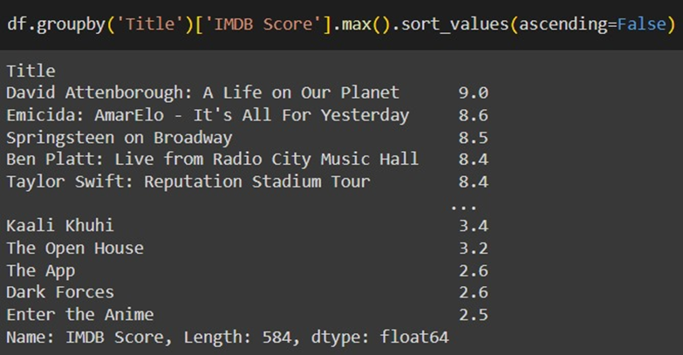

*The highest rating of the film*

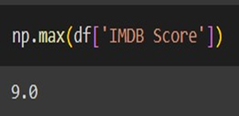

*The film which has the runtime equal to or more than 180 minutes*

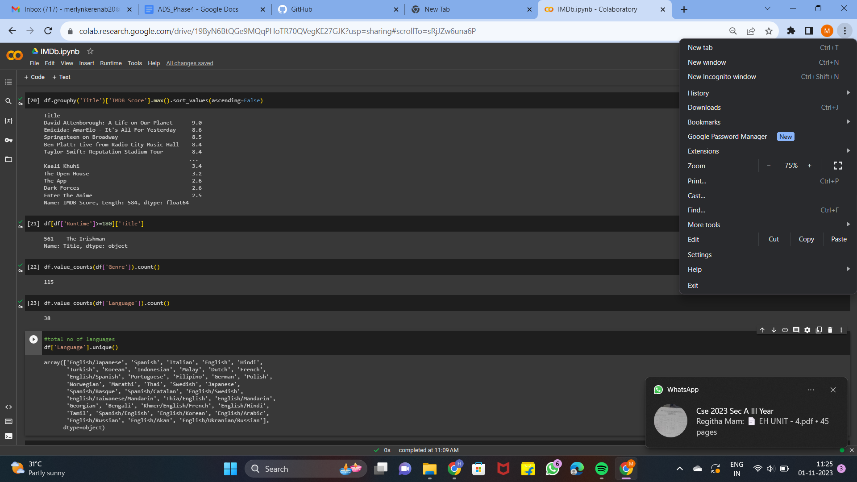

*Total number of genre in the dataset*

**

*Total number languages in the dataset*

**

*The languages in the dataset*

**

*Which language has the highest number of films in a genre*

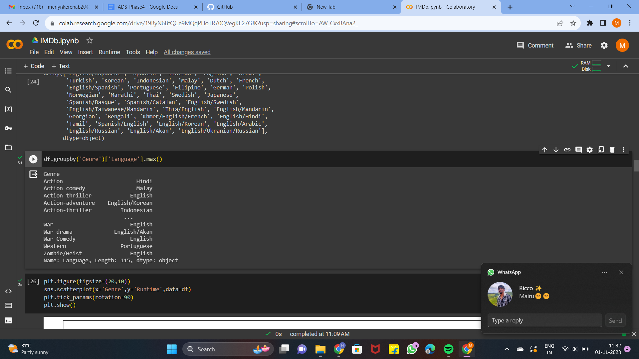

*A plot to analyze the relationship between Runtime and Genre*

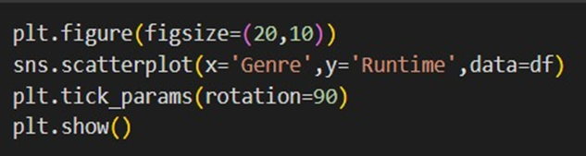

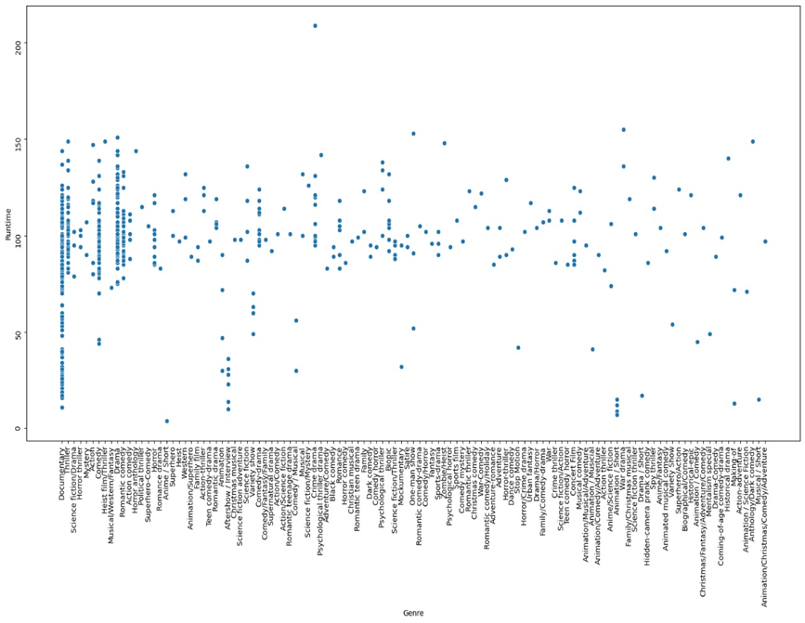

*A plot to analyze the relationship between IMDb Score and Runtime*

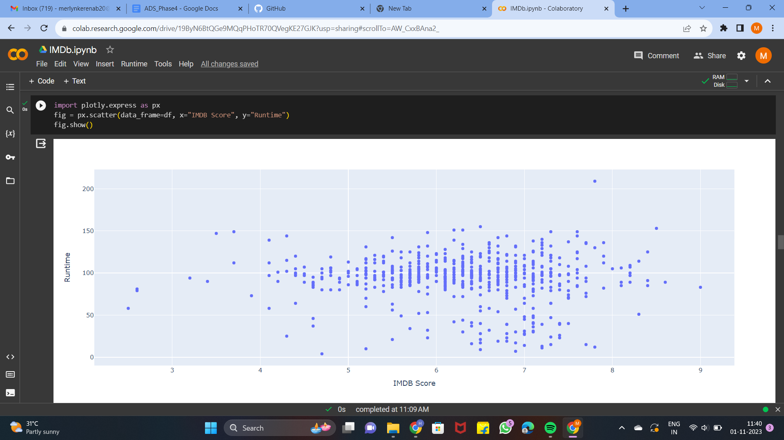

Data preprocessing ensures that the data is clean, consistent, and suitable for the tasks at hand. By following the steps outlined in this report and using the appropriate techniques and libraries, the given dataset has been pre-processed in python for accurate and meaningful analysis.

**Feature engineering**

Feature engineering is the process of transforming raw data into features that are suitable for machine learning models. In other words, it is the process of selecting, extracting, and transforming the most relevant features from the available data to build more accurate and efficient machine learning models.

We have implemented certain Feature extraction process in the given dataset like extracting the columns ‘Date’ , ‘Year’ and ‘Month’ from the Premiere column that was already existing in the given dataset 2 3 The Feature extraction process in the given dataset like extracting the columns ‘Date’ , ‘Year’ and ‘Month’ from the Premiere column that was already existing in the given dataset

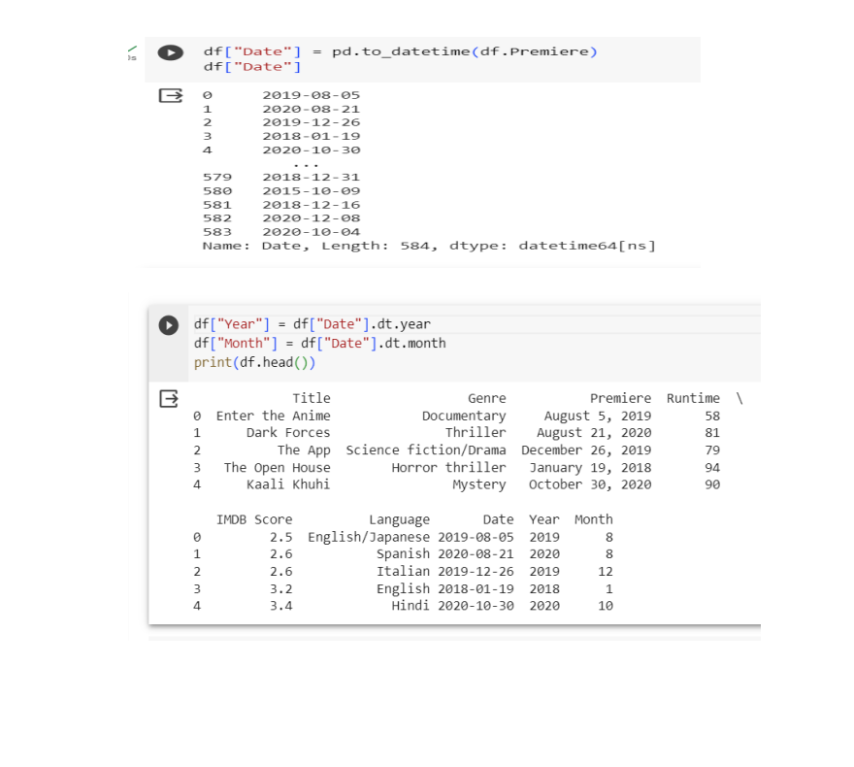

Pairplot

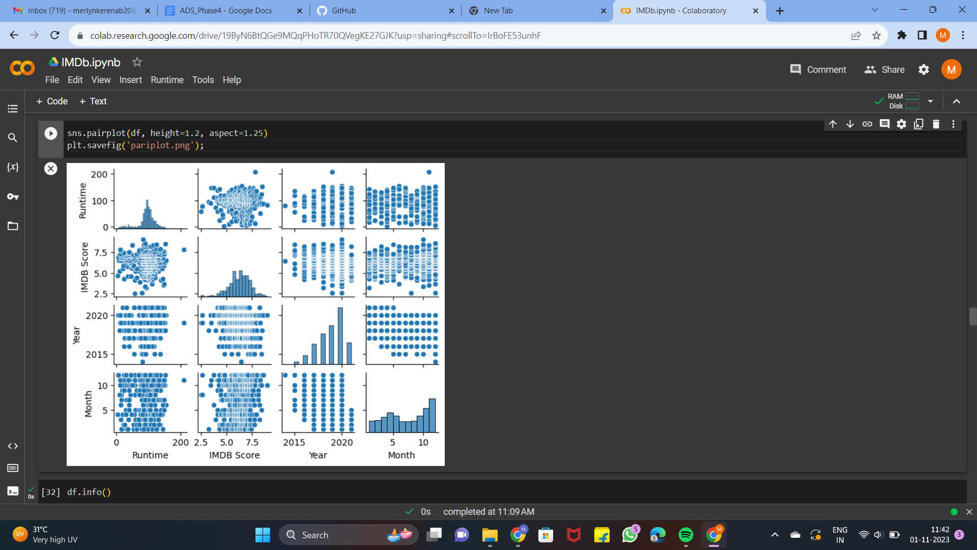

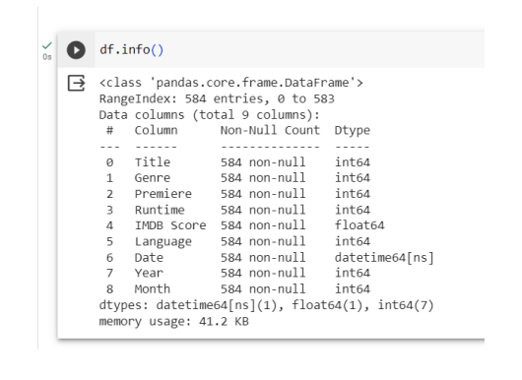

The *Feature transformation* was implemented by the use of Label encoder to convert the categorical values into numeric values.

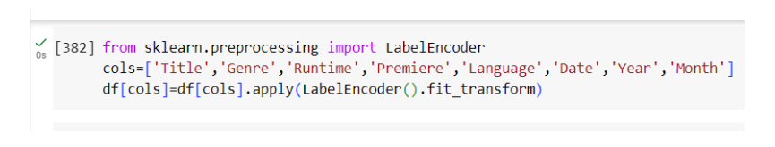

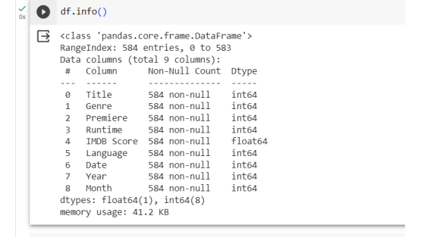

The *Feature selection* is used to choose the most relevant features to include in the model while eliminating irrelevant or redundant ones. Therefore, we have excluded ‘Premiere’ and ‘Month’.

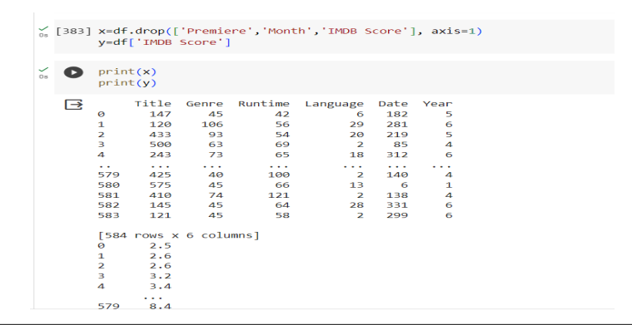

*Splitting of data* - The dataset is divided into training and test sets. The training set is used to train the model and the test set is used to evaluate the model's generalization performance

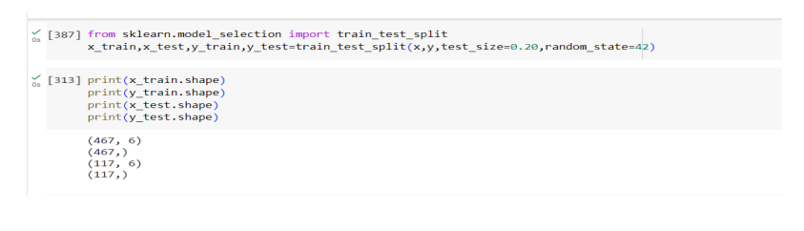

**Model Building**

By choosing a machine learning algorithm a model is build for Predicting the IMDb Scores for the given dataset

**Why Random Forest Regressor?**

Since we need to build a predictive model for continuous data , we have to go for a Regressor model. Random Forest Regressor is an ensemble model and hence the accuracy will be better and since it can work with non linear data and reduces outliers and overfitting we have chosen Random forest Regressor. And among all the models we tried Random Forest Regressor gave a better predictive model with less error value.

**Model Training**

Train the model on the training dataset. The model learns the patterns and relationships in the data during this phase.

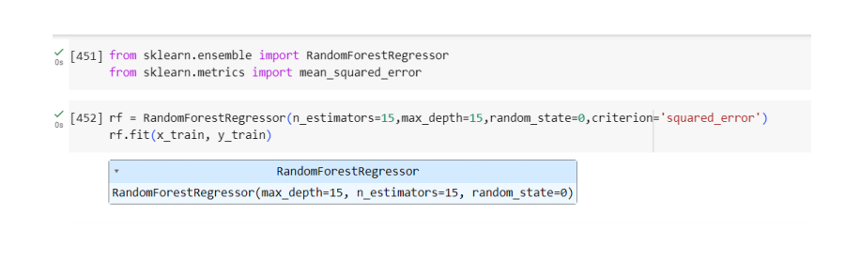

**Model Validation**

Validate the model on the test set to assess its generalization performance. This step ensures that the model can make accurate predictions on unseen data.

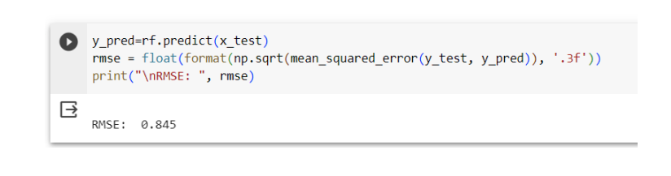

**Model Evaluation**

Evaluation metrics for regression models are used to assess the performance of models that predict continuous numeric values. These metrics help to understand how well the regression model is making predictions and are crucial for model selection, hyperparameter tuning, and comparing different regression algorithms. Here are some common evaluation metrics for regression models:

1. Mean Absolute Error (MAE):

- Measures the average absolute difference between actual and predicted values.

- Calculation: (1/n) Σ |actual - predicted|

2. Mean Squared Error (MSE):

- Measures the average of the squared differences between actual and predicted values.

- Calculation: (1/n) Σ (actual - predicted)^2

3. Root Mean Squared Error (RMSE):

- It is the square root of the mean squared error.

- Calculation: √MSE

4. R-squared (R2) Score:

- Measures the proportion of the variance in the dependent variable that is predictable from the independent variables.

- Calculation: 1 - (MSE(model) / MSE(mean))

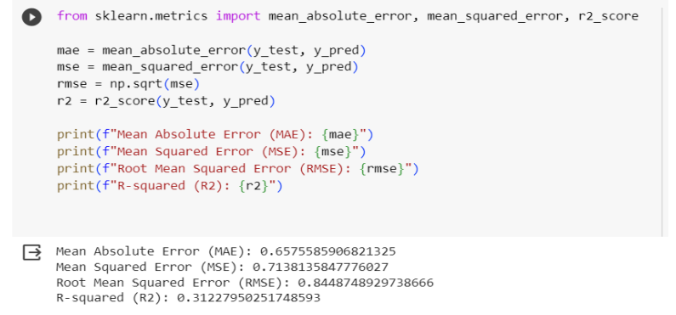

**Visualization of Random Forest Regression**

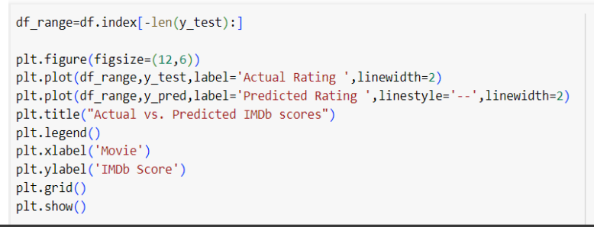

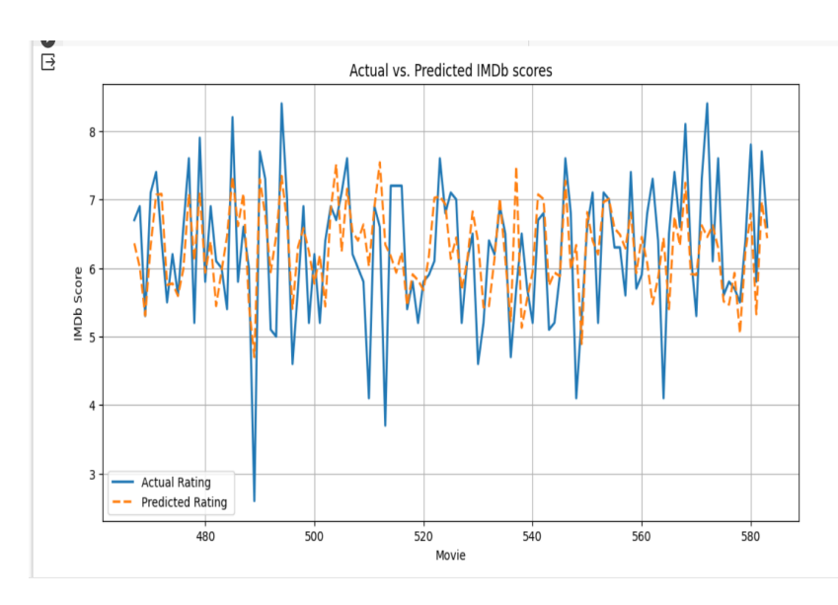

**Other Models We Built**

**1. Linear Regression**

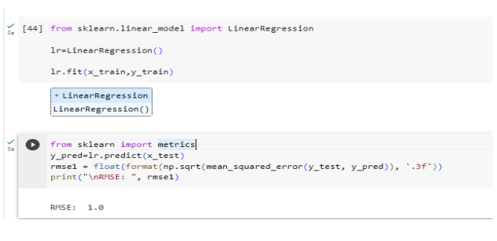

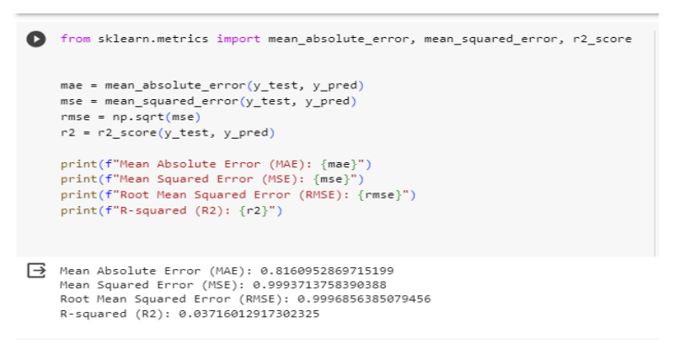

**2. Decision Tree**

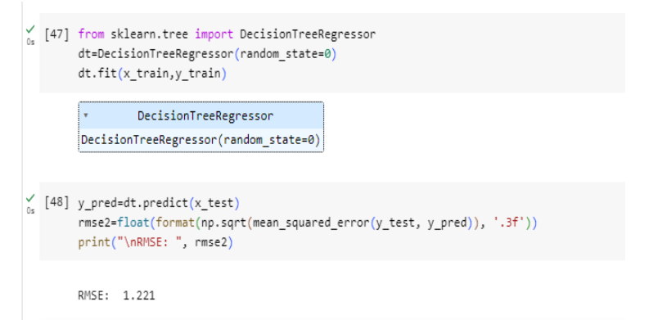

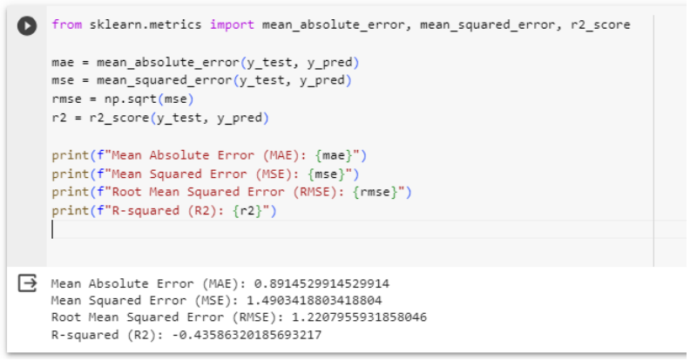

**3. Support Vector Regressor**

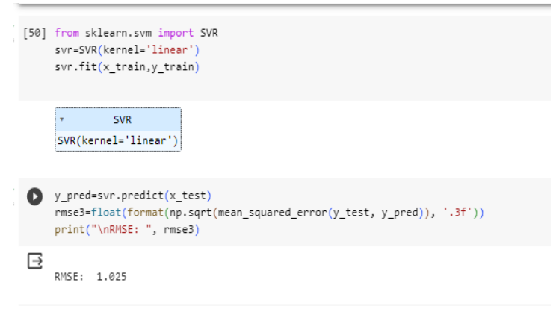

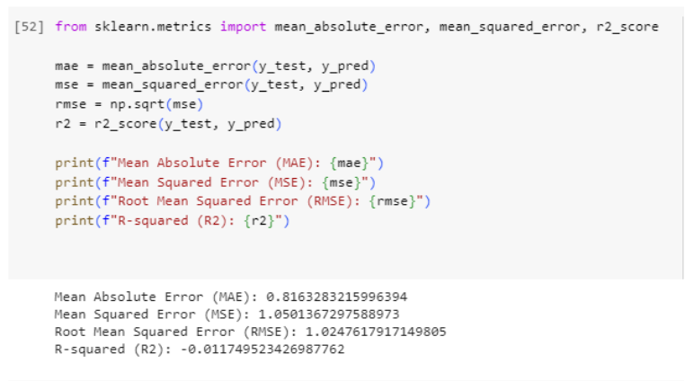

**4. Gradient Boosting Regressor**

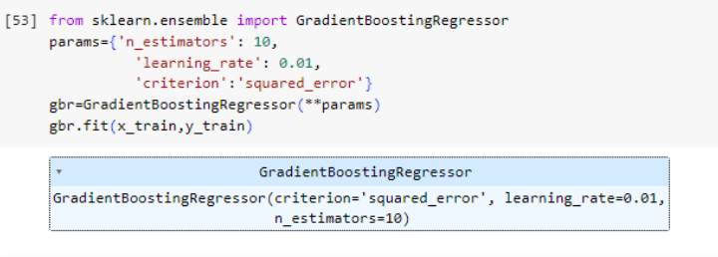

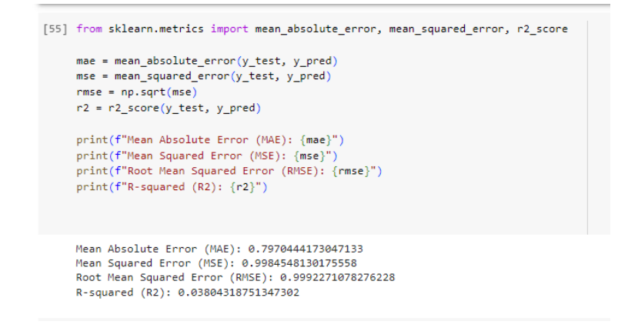

**5. Polynomial Regression**

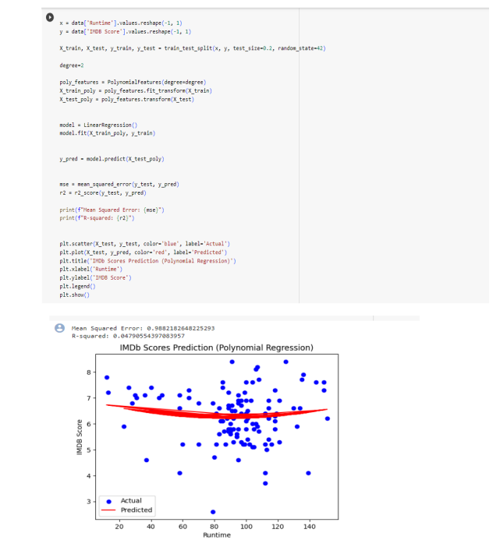



**6.Logistic Regression**

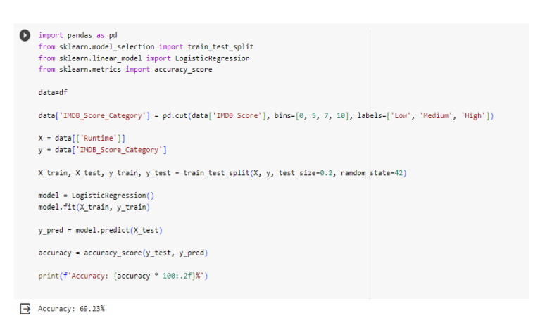

**The Link of the Colab Notebook we worked on :**

[**https://colab.research.google.com/drive/19ByN6BtQGe9MQqPHoTR70QVegKE27GJK?usp=sharing**](https://colab.research.google.com/drive/19ByN6BtQGe9MQqPHoTR70QVegKE27GJK?usp=sharing)

**CONCLUSION**

Predicting IMDb scores is a complex task that involves analyzing various factors such as plot, acting, direction, and audience reception. Through advanced statistical models and machine learning algorithms, researchers and data scientists can make predictions based on these factors. However, it's important to note that while these predictions can be accurate to some extent, they can't account for personal preferences and individual opinions, which play a significant role in a movie's success. Therefore, while predictive models provide valuable insights, the ultimate judgment of a movie's quality still lies in the subjective opinions of the viewers.